Community Empowerment-Based Agrotourism Outreach in Rice Fields of Dusun III, Sei Naga Lawan Village, Perbaungan District, Serdang
Bedagai Regency, North Sumatra.
Novita Romauli Saragih ¹⁾, Selamat Karo-karo ²⁾, Padriadi Wiharjokusumo ³⁾, Dameria Girsang ⁴⁾
Corresponding Authors: novitaromauli12@gmail.com ¹⁾, selamatkaro@gmail.com²⁾, knb.ministry76@gmail.com ³⁾, mberhul@gmail.com ⁴⁾

ABSTRACT
This community service activity aimed to increase public awareness of the potential for rice field-based agrotourism in Dusun III, Sei Naga Lawan Village, Perbaungan District, Serdang Bedagai Regency, North Sumatra. The program was carried out on September 18–19, 2025, through a series of outreach activities consisting of counseling sessions, group discussions, and field observations. The participants included 34 people from various community groups such as farmers, youth organizations, village officials, and local MSME actors. The results of the activity showed that the participants began to understand the concept and economic potential of rice field agrotourism and expressed interest in developing similar programs in their area. This community empowerment-based approach is expected to serve as an initial step toward creating sustainable agrotourism that can enhance the local economy while preserving the village’s agricultural identity.
Keywords: Agrotourism; Community Empowerment; Public Awareness; Rural Development; Sei Naga Lawan.

ABSTRAK
Kegiatan pengabdian kepada masyarakat ini bertujuan untuk meningkatkan kesadaran masyarakat terhadap potensi agrowisata berbasis sawah di Dusun III, Desa Sei Naga Lawan, Kecamatan Perbaungan, Kabupaten Serdang Bedagai, Provinsi Sumatera Utara. Program ini dilaksanakan pada tanggal 18–19 September 2025 melalui serangkaian kegiatan sosialisasi yang meliputi penyuluhan, diskusi kelompok, dan observasi lapangan. Peserta kegiatan berjumlah 34 orang yang terdiri dari berbagai kelompok masyarakat, seperti petani, pemuda desa, aparat desa, serta pelaku UMKM setempat. Hasil kegiatan menunjukkan bahwa para peserta mulai memahami konsep dan potensi ekonomi dari agrowisata sawah, serta menunjukkan ketertarikan untuk mengembangkan program serupa di wilayah mereka. Pendekatan berbasis pemberdayaan masyarakat ini diharapkan dapat menjadi langkah awal dalam menciptakan agrowisata berkelanjutan yang mampu meningkatkan perekonomian lokal sekaligus menjaga identitas pertanian desa.
Kata Kunci: Agrowisata; Pemberdayaan Masyarakat; Kesadaran Publik; Pembangunan Pedesaan; Sei Naga Lawan.

INTRODUCTION
Agrotourism has emerged as a sustainable approach to integrate agricultural activities with tourism, aiming to enhance rural livelihoods and preserve local culture. According to Barbieri and Mahoney (2009), agrotourism serves as a strategic instrument for rural development by diversifying farmers’ income sources and strengthening the socio-economic fabric of rural communities. Similarly, Philip, Hunter, and Blackstock (2010) argue that agrotourism provides not only economic benefits but also educational and environmental values, fostering a deeper appreciation of agricultural heritage among visitors.
In Indonesia, the potential for developing agrotourism is significant due to its vast agricultural land and cultural diversity. However, in many rural areas, this potential remains underutilized because of low public awareness, limited skills in tourism management, and insufficient institutional support (Sastrayuda, 2010). Therefore, community empowerment has become a crucial component in the success of rural-based tourism programs. As Chambers (1997) emphasizes, empowerment enables local people to take control over decisions and resources that affect their lives, which is essential for ensuring the sustainability of community-based projects.
The village of Sei Naga Lawan in Perbaungan District, Serdang Bedagai Regency, North Sumatra, possesses wide rice fields and a rich agricultural tradition that can serve as the foundation for developing agrotourism. However, before such initiatives can flourish, the local community must first recognize and appreciate the economic and cultural value of agrotourism. This community service program, therefore, was designed to raise awareness among farmers, village youth, and local business actors about the potential of rice field–based agrotourism.
The activity was conducted through a participatory approach that combined counseling, group discussions, and field observations. These methods aimed to stimulate critical thinking, encourage dialogue, and foster collaboration between stakeholders. The expected outcome of this initiative is the emergence of community motivation to develop agrotourism sites that not only increase household income but also maintain the agricultural identity of the village. By integrating empowerment principles and local wisdom, this program supports Indonesia’s broader agenda for sustainable rural development in alignment with the United Nations’ Sustainable Development Goals (SDGs), particularly Goal 8 (Decent Work and Economic Growth) and Goal 11 (Sustainable Cities and Communities).

B. OBJECTIVE
The main objective of this Community Service Program (CSP) is to enhance public awareness and understanding of the potential for rice field–based agrotourism as a sustainable form of rural development in Dusun III, Sei Naga Lawan Village, Perbaungan District, Serdang Bedagai Regency, North Sumatra. The program aims to empower local communities—particularly farmers, youth groups, village officials, and micro, small, and medium enterprise (MSME) actors—to recognize and utilize agricultural land not only as a means of livelihood but also as a tourism asset that reflects local culture and environmental sustainability.
This initiative seeks to:
- Strengthen community knowledge of the economic, educational, and environmental benefits of rice field–based agrotourism;
- Encourage active participation of local residents in the planning and management of community-based tourism;
- Promote the application of empowerment principles as proposed by Chambers (1997), emphasizing people-centered, participatory, and sustainable development; and
- Serve as a pilot model for integrating agricultural productivity with tourism development, in line with Indonesia’s national agenda for rural innovation (Wiharjokusumo, 2020; Panggabean et al., 2022).
Through these objectives, the program aspires to initiate a transformative shift in local perspectives—enabling the community to view agriculture not merely as subsistence but as an integral component of creative and sustainable tourism development.
C. METHOD OF IMPLEMENTATION
This Community Service Program (CSP) was implemented using a participatory and empowerment-based approach that emphasizes active community involvement in every stage of the activity. The implementation was carried out on September 18–19, 2025, in Dusun III, Sei Naga Lawan Village, Perbaungan District, Serdang Bedagai Regency, North Sumatra, on the agricultural land of PT. Wira Pradana Mukti and PT. Sarah Sentosa Sejahtera.
1. Program Design
The program was designed based on the principles of community-based tourism and sustainable agricultural management. According to Wiharjokusumo (2020), the development of rural tourism requires a synergistic relationship between local potential, cultural values, and community participation. Therefore, the activity structure included counseling sessions, group discussions, and field observations, ensuring that the learning process was both experiential and reflective (Sihombing et al., 2023).
2. Stages of Implementation
The implementation consisted of three main stages:
- Preparation Stage
This stage included coordination with the Village Government of Sei Naga Lawan, permission requests to PT. Wira Pradana Mukti and PT. Sarah Sentosa Sejahtera, identification of local needs, and the preparation of teaching materials and presentation media. The planning was aligned with the Pentahelix collaboration model (government, academia, business, community, and media), as discussed by Panggabean, Tondang, and Wiharjokusumo (2022), to ensure holistic engagement.
- Implementation Stage
The outreach activities were divided into three main sessions:
- Counseling Session: Delivering material on the concept, benefits, and models of agrotourism, including examples of successful rural tourism programs in North Sumatra (Wiharjokusumo, Saragih, & Malau, 2021).
- Group Discussion: Facilitating dialogue between farmers, youth, and MSME actors to explore potential agrotourism ideas and collaborative management strategies.
- Field Observation: Conducted in rice field areas to identify environmental, cultural, and infrastructural potentials that could be developed into agrotourism attractions.

- Evaluation Stage
The evaluation process involved three instruments: (1) observation of participant engagement, (2) short interviews to capture perceptions and motivation, and (3) reflection sessions to discuss insights and proposed follow-up actions. This triangulation ensured the validity of results and community feedback (Wiharjokusumo, 2021).
3. Participants
A total of 34 participants took part in the program, consisting of farmers, youth, village officials, and MSME actors. Their participation demonstrated a high level of enthusiasm and collective interest in exploring agrotourism development opportunities.
4. Implementation Team
The activity was facilitated by four lecturers from Universitas Darma Agung and Akademi Pariwisata & Darma Agung, namely:
- Dr. (Cand.) Novita Romauli Saragih, S.H., S.Th., M.Th., M.Pd.
- Dr. Selamat Karo-Karo, S.Th., M.Th., M.Pd.
- Dr. Pariadi Wiharjokusumo, S.S., S.H., M.H.
- Dr. Dameria Girsang, S.Sos., M.M., M.Si.
Their interdisciplinary expertise in education, tourism, law, and social sciences strengthened the methodological integration between empowerment and sustainable tourism development.
D. RESULT AND DISCUSSION
1. Overview of Activity Results
The Community Service Program (CSP) on Community Empowerment-Based Agrotourism Outreach in Rice Fields was successfully implemented with active participation from 34 community members, including farmers, youth, village officials, and MSME actors. The activities—consisting of counseling sessions, group discussions, and field observations—created an interactive learning atmosphere that encouraged local engagement and reflection on the economic potential of rice field–based tourism.
The high level of enthusiasm demonstrated by participants reflected the community’s openness to innovation and their growing awareness of agrotourism as an alternative livelihood strategy. As noted by Wiharjokusumo, Saragih, and Malau (2021), the success of rural tourism programs depends greatly on local participation and cross-sector collaboration.
A visual summary of the participants’ level of engagement and feedback is presented in Figure 1, showing that 88% of attendees expressed satisfaction and interest in developing agrotourism projects after the outreach session.
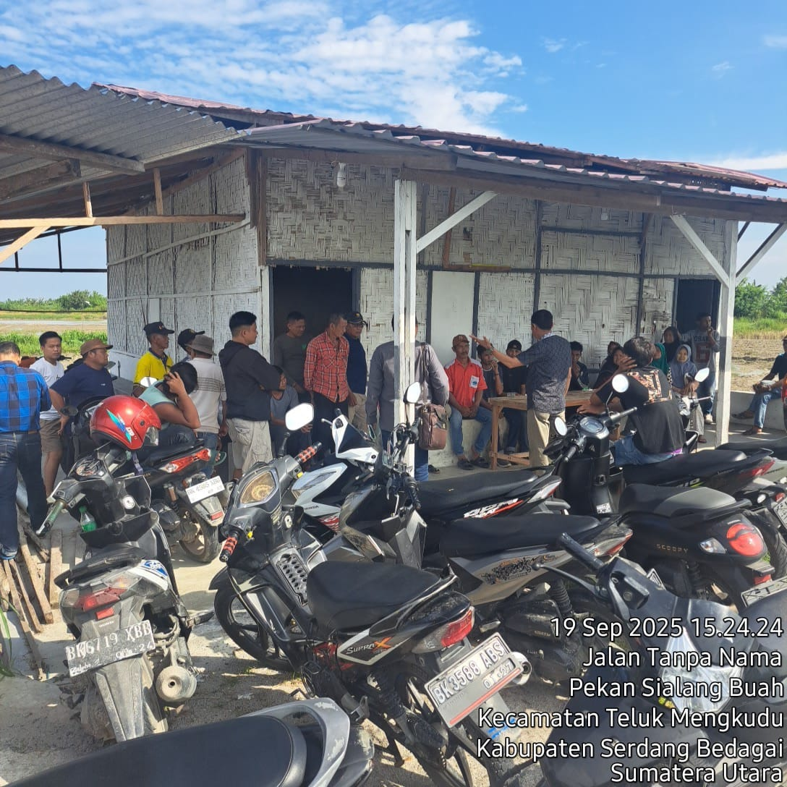
Figure 1, showing that 88% of attendees expressed satisfaction and interest in developing agrotourism projects after the outreach session.
2. Community Awareness Improvement
To assess the effectiveness of the program, participants’ awareness and motivation were measured before and after the activity. The indicators were related to their understanding of agrotourism, interest in tourism development, and readiness to collaborate.
Indicator | Before Program | After Program | Change (%)
Understanding of agrotourism concept | 35% | 82% | +47%
Interest in developing agrotourism | 41% | 88% | +47%
Motivation to collaborate | 50% | 90% | +40%
Table 1. Comparison of participants’ understanding and motivation before and after the program.
The data show a clear increase in both awareness and willingness to engage in agrotourism-related initiatives. This result supports the empowerment model proposed by Chambers (1997), emphasizing that participatory learning stimulates intrinsic motivation and collective action.
Similarly, Panggabean, Tondang, and Wiharjokusumo (2022) found that integrating the Pentahelix collaboration model—involving government, academia, business, community, and media—can strengthen rural innovation systems and accelerate tourism-based economic development.
3. Theoretical and Practical Implications
The findings confirm that the empowerment approach used in this CSP effectively improved local capacities and attitudes toward sustainable agrotourism. As highlighted by Sihombing et al. (2023), socialization and participatory training are key drivers of behavioral change in community-based tourism programs.
In this case, the combination of experiential learning and interactive discussion proved to be the most effective method. Participants actively exchanged ideas, shared experiences, and proposed strategies for managing tourism activities based on local culture and environmental conservation. Such engagement aligns with Wiharjokusumo’s (2020) view that the essence of ecotourism and agrotourism lies in harmonizing economic growth, community empowerment, and environmental balance.
Moreover, the participatory learning atmosphere enabled participants to reflect critically on their social and ecological context, which is consistent with the empowerment framework of Chambers (1997) and the constructivist pedagogical perspective promoted by Wiharjokusumo (2021).
4. Visual Documentation and Community Engagement
The documentation presented in Figure 2 captures several stages of the activity, including community discussions, field observations, and presentations of agrotourism development ideas. The images illustrate genuine enthusiasm, collaboration, and creativity among participants.
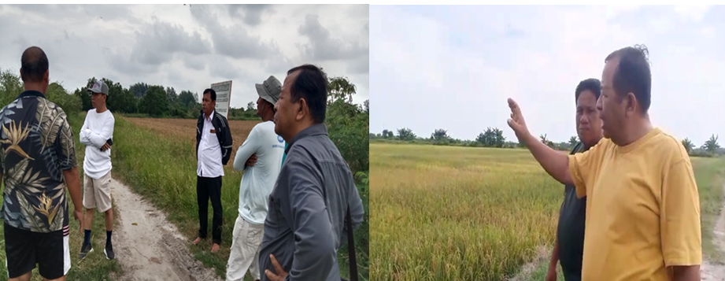

Figure 2 captures several stages of the activity, including community discussions, field observations, and presentations of agrotourism development ideas.
These visual evidences not only enrich the qualitative analysis but also demonstrate the tangible outcomes of community-based outreach, where learning occurs through participation and dialogue.
5. Interpretation and Impact
The overall results indicate that the outreach program successfully increased local awareness and interest in developing agrotourism as an alternative source of income. This aligns with previous studies that emphasize the transformative role of community empowerment in rural tourism (Wiharjokusumo, 2023; Saragih et al., 2025).
Beyond knowledge acquisition, participants expressed a new sense of pride and ownership over their agricultural landscape, perceiving it not merely as farmland but as a cultural and economic asset. This change in perspective is crucial for long-term sustainability and for fostering inclusive development in rural North Sumatra.
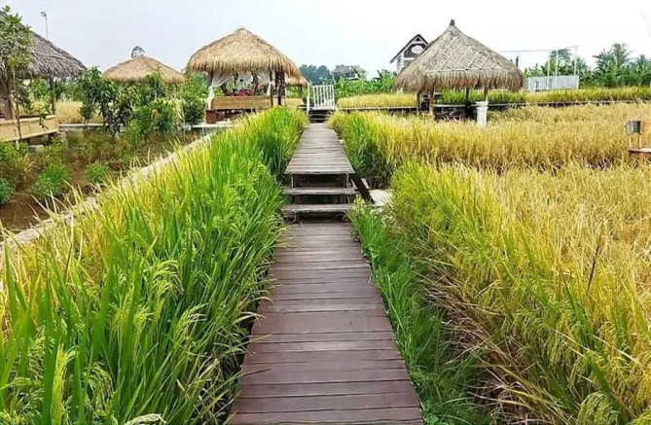
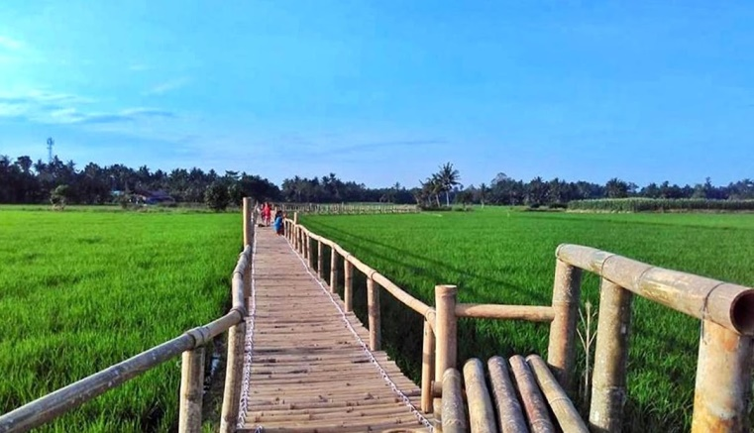
In conclusion, the findings demonstrate that community-based agrotourism initiatives—when guided by participatory empowerment models—can effectively promote local innovation, environmental stewardship, and socio-economic resilience in rural areas.

Figure 3. Model of Rice Field Ecotourism in Dusun III, Sei Naga Lawan Village.
This model envisions a community-based agrotourism area that integrates agriculture, culture, and education through participatory activities. It promotes sustainable rural development by empowering local farmers and youth under the Pentahelix collaboration framework.

E. CONCLUSION
The implementation of the Community Service Program (CSP) on Community Empowerment-Based Agrotourism Outreach in Rice Fields of Dusun III, Sei Naga Lawan Village, Perbaungan District, Serdang Bedagai Regency has proven to be an effective approach in increasing public awareness and participation in sustainable rural tourism development.
Through a combination of counseling, group discussion, and field observation, the program succeeded in introducing the concept of agrotourism not only as an economic activity but also as a means of cultural preservation and environmental stewardship. The data analysis showed a significant increase in participants’ understanding and motivation—demonstrating that empowerment-based outreach can transform community perspectives and attitudes toward agricultural land use.
Furthermore, this initiative has encouraged collaborative thinking among different local actors, fostering a multi-stakeholder framework aligned with the Pentahelix model (Panggabean et al., 2022). As Wiharjokusumo (2020) emphasizes, the development of rural tourism must be rooted in community participation and local wisdom to ensure long-term sustainability.
Overall, the CSP has successfully achieved its objectives by creating a foundation for community-driven agrotourism in Sei Naga Lawan Village. The enthusiasm and initiative shown by participants reflect the potential for replicating similar programs in other rural areas across North Sumatra and beyond.
F. RECOMMENDATION
To ensure the sustainability of the empowerment outcomes, it is recommended that local stakeholders—particularly the village government, farmer groups, and youth organizations—continue collaborative efforts to develop rice field–based agrotourism as a long-term economic and cultural initiative. Follow-up activities such as advanced training, digital promotion, and partnership programs with universities and private sectors should be encouraged to strengthen community capacity and market visibility. By maintaining participatory engagement and aligning with sustainable development principles, Sei Naga Lawan Village can serve as a model for community-driven agrotourism development in North Sumatra and across Indonesia.

G. ACKNOWLEDGMENT
The authors would like to express their sincere gratitude to the Village Government of Sei Naga Lawan, PT. Wira Pradana Mukti, and PT. Sarah Sentosa Sejahtera for their support and permission to carry out the Community Service Program on rice field–based agrotourism. Deep appreciation is also extended to all farmers, youth representatives, MSME actors, and village officials who actively participated and contributed to the success of the program. Special thanks are conveyed to Universitas Darma Agung and the Tourism and Hotel Academy of Darma Agung for providing institutional support, resources, and academic collaboration that made this outreach possible. May this partnership continue to inspire further initiatives that empower local communities and promote sustainable rural development in North Sumatra.

REFERENCES
Albrecht, G. (1995). The Character of Our Communities: Toward an Ethic of Liberation for the Church. Abingdon Press.
Bandura, A. (1977). Social Learning Theory. Prentice-Hall.
Barbieri, C., & Mahoney, E. (2009). Why is diversification an attractive farm adjustment strategy? Journal of Rural Studies, 25(1), 58–66.
Berkowitz, M. (2012). Character education: Theory and practice. Journal of Moral Education, 35, 495–518.
Panggabean, D., Tondang, B., & Wiharjokusumo, P. (2022). Analisis efektivitas BUMDes dalam meningkatkan kunjungan wisatawan melalui model Pentahelix di Desa Wisata Silalahi II, Kecamatan Silahisabungan, Kabupaten Dairi. Jurnal Creative Agung.
Philip, S., Hunter, C., & Blackstock, K. (2010). A typology for defining agritourism. Tourism Management, 31(6), 754–758.
Saragih, N. R., Karo-Karo, S., Wiharjokusumo, P., & Girsang, D. (2025). Community service program: Socialization and training for Sunday school teachers in developing children’s character at GBI Avia Cemara Church, Medan. Jurnal Pengabdian Kepada Masyarakat Agung.
_______ (2024). The role of Christian religious education teachers in enhancing student academic achievement in Grade VIII-3 at State Junior High School 7 Medan, Academic Year 2024. Jurnal UDA. DOI: http://dx.doi.org/10.46930/ojsuda.v32i6.5189
Sastrayuda, G. S. (2010). Konsep Pengembangan Desa Wisata dan Pemberdayaan Masyarakat. Bandung: Universitas Pendidikan Indonesia.
Sihombing, B., Tarigan, N., & Wiharjokusumo, P. (2023). Promosi potensi pariwisata melalui pemanfaatan media sosial. Jurnal Pengabdian Kepada Masyarakat Agung.
Wiharjokusumo, P. (2020). Kebijakan perencanaan dan pembangunan desa ekowisata dan pariwisata di Indonesia. Jurnal Ilmiah Akomodasi Agung.
______ Rahasia Sukses Membangun Mental Melalui Kecerdasan Spiritual dan Emosional dalam Meraih Keberhasilan Berdasarkan 5 Prinsip Kemenangan dan Hukum Kasih. CV Media Sains Indonesia, Bandung.
______(2022). Pengaruh penerapan cleanliness, health, safety, dan environmental sustainability terhadap kepuasan tamu di Hotel Harper Wahid Hasyim Medan. Jurnal Prointegrita.
______(2021). Bakti sosial pariwisata pengabdian pada masyarakat Desa Pantai Cermin Kanan, Kabupaten Serdang Bedagai. Jurnal Pengabdian Kepada Masyarakat Agung.
______(2021). Overview of the potential development of natural tourism objects and attractions of Pantai Cemara Indah Gosong Telaga in North Singkil Sub-District, Aceh Singkil Regency. Jurnal Ilmiah Akomodasi Agung.
______(2023). Peluang dan tantangan pengembangan wisata religi di Taman Wisata Iman, Sitinjo Dairi. Jurnal Ilmiah Akomodasi Agung.
Williandani, M., Tambunan, I. B., Napitupulu, B. P., & Tarigan, N. (2023). Membangun keramah-tamahan dalam konsep Sapta Pesona untuk mengangkat potensi wisata Danau Toba di Desa Parparean, Kecamatan Porsea, Kabupaten Toba, Provinsi Sumatra Utara, Indonesia. Jurnal Pengabdian Kepada Masyarakat Agung.

